**Experiment Number: 01**

**Experiment Name:** Implementation and Analysis of Impulse, Step, and Ramp Functions in Discrete-Time Signals

**Objectives:**

1. To understand and implement fundamental discrete-time signals Unit Impulse (Dirac Delta) Function, Unit Step Function, Unit Ramp Function

2. To visualize these signals using Python (NumPy & Matplotlib).

3. To analyze their mathematical representations and behaviors in discrete-time domains.

4. To establish a foundation for signal processing applications like convolution and system analysis.

**Theory:** In Digital Signal Processing (DSP), three fundamental discrete-time signals are commonly used:

1️. Unit Impulse Function (δ[n]):

* Defined as 1 at n = 0, and 0 elsewhere.
* Used to test system responses and as a building block for other signals.

2. Unit Step Function (u[n]):

* Defined as 1 for n ≥ 0, and 0 for n < 0.
* Represents systems that turn on at a certain time.
* Integral (summation) of the impulse function.

3. Unit Ramp Function (r[n]):

* Defined as n for n ≥ 0, and 0 for n < 0.
* Represents a linearly increasing signal over time.
* Integral (summation) of the step function.

These signals are fundamental for analyzing and designing digital systems, helping in convolution, system response analysis, and control system

**Source Code:**

import numpy as np

import matplotlib.pyplot as plt

# Define functions

def impulse_signal(n):

return np.where(n == 0, 1, 0) # δ[n] = 1 for n=0, else 0

def step_signal(n):

return np.where(n >= 0, 1, 0) # u[n] = 1 for n >= 0, else 0

def ramp_signal(n):

return np.where(n >= 0, n, 0) # r[n] = n for n >= 0, else 0

# Generate signals

n1 = np.arange(-10, 11) # For impulse and step

n2 = np.arange(-5, 6) # For ramp

impulse = impulse_signal(n1)

step = step_signal(n1)

ramp = ramp_signal(n2)

# Create a figure with 3 subplots

plt.figure(figsize=(10, 6))

# Plot Unit Impulse Function

plt.subplot(3, 1, 1)

plt.stem(n1, impulse, use_line_collection=True)

plt.xlabel('n')

plt.ylabel('δ[n]')

plt.title('Unit Impulse Function')

plt.grid(True)

# Plot Unit Step Function

plt.subplot(3, 1, 2)

plt.stem(n1, step, use_line_collection=True)

plt.xlabel('n')

plt.ylabel('u[n]')

plt.title('Unit Step Sequence')

plt.grid(True)

# Plot Unit Ramp Function

plt.subplot(3, 1, 3)

plt.stem(n2, ramp, use_line_collection=True)

plt.xlabel('n')

plt.ylabel('r[n]')

plt.title('Ramp Function')

plt.grid(True)

# Adjust layout and show plot

plt.tight_layout()

plt.show()

**Output:**

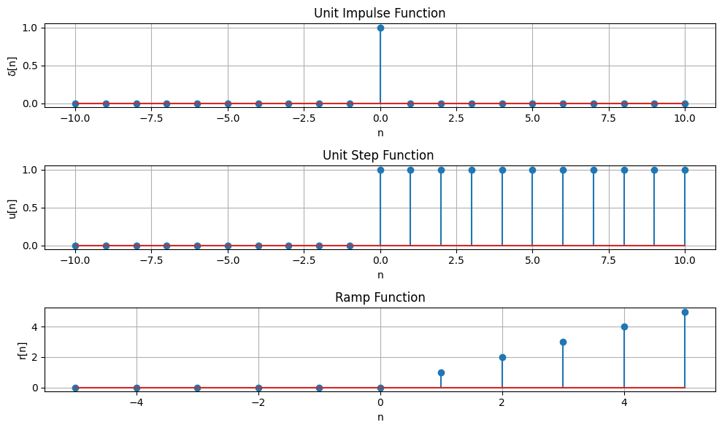

**Figure 01: Unit Impulse, Unit Step, and Ramp Function**

**Experiment Number: 02**

**Experiment Name:** Basic Operations on Discrete-Time Signals: Addition, Subtraction, Multiplication, Shifting, and Folding

**Objectives:**

1. Addition, Subtraction, Multiplication: These operations modify signal amplitude by combining or altering values at each index.
2. Shifting: Moves a signal left (advance) or right (delay), affecting its alignment in time.
3. Folding: Flips the signal horizontally, reversing its time indices.

**Theory:** Discrete-time signals are sequences of values defined at specific time indices. Several fundamental operations can be performed on these signals:

* Addition: Adds two signals element-wise, combining their amplitudes.
* Subtraction: Subtracts one signal from another, showing differences at each index.
* Multiplication: Multiplies two signals element-wise, affecting their amplitudes.
* Shifting: Moves a signal left (advance) or right (delay) in time by a given shift value.
* Folding: Reverses the signal along the time axis, flipping it horizontally.

These operations are essential in signal processing, filtering, and transformation analysis.

**Source Code:**import numpy as np

import matplotlib.pyplot as plt

# Define two signals

x1 = np.array([1, 2, 3, 4, 5]) # First signal

x2 = np.array([5, 4, 3, 2, 1]) # Second signal

# Perform basic operations

y_add = x1 + x2 # Addition

y_sub = x1 - x2 # Subtraction

y_mul = x1 * x2 # Multiplication

# Define index range

n = np.arange(len(x1))

# Create a figure

plt.figure(figsize=(10, 8))

# Plot Original Signal x1

plt.subplot(5, 1, 1)

plt.stem(n, x1, markerfmt='bo')

plt.title('Original Signal x1')

plt.xlabel('n')

plt.ylabel('x1(n)')

plt.grid(True)

# Plot Original Signal x2

plt.subplot(5, 1, 2)

plt.stem(n, x2, markerfmt='ro')

plt.title('Original Signal x2')

plt.xlabel('n')

plt.ylabel('x2(n)')

plt.grid(True)

# Plot Addition

plt.subplot(5, 1, 3)

plt.stem(n, y_add, markerfmt='go')

plt.title('Signal Addition')

plt.xlabel('n')

plt.ylabel('x1(n) + x2(n)')

plt.grid(True)

# Plot Subtraction

plt.subplot(5, 1, 4)

plt.stem(n, y_sub, markerfmt='mo')

plt.title('Signal Subtraction')

plt.xlabel('n')

plt.ylabel('x1(n) - x2(n)')

plt.grid(True)

# Plot Multiplication

plt.subplot(5, 1, 5)

plt.stem(n, y_mul, markerfmt='co')

plt.title('Signal Multiplication')

plt.xlabel('n')

plt.ylabel('x1(n) * x2(n)')

plt.grid(True)

# Adjust layout

plt.tight_layout()

plt.show()

# ----------------- Signal Shifting and Folding -----------------

# Function for signal shifting

def signal_shifting(n, shift):

return n + shift # Shift indices by given amount

# Function for signal folding (time reversal)

def signal_folding(x):

return np.flip(x) # Reverse the signal values

# Define the original signal and indices

n = np.array([-2, -1, 0, 1, 2]) # Time indices

x1 = np.array([1, 2, 3, 4, 5]) # Signal values

# Perform shifting (Right shift by 2)

n_shifted = signal_shifting(n, 2)

# Perform folding (Time reversal)

x_folded = signal_folding(x1)

# Plot the original signal

plt.figure(figsize=(10, 6))

plt.subplot(3, 1, 1)

plt.stem(n, x1, markerfmt='bo')

plt.title('Original Signal')

plt.xlabel('n')

plt.ylabel('x(n)')

plt.grid(True)

# Plot shifted signal (Right shift by 2)

plt.subplot(3, 1, 2)

plt.stem(n_shifted, x1, markerfmt='ro')

plt.title('Shifted Signal (Right Shift by 2)')

plt.xlabel('n')

plt.ylabel('x(n-2)')

plt.grid(True)

# Plot folded signal (Time Reversal)

plt.subplot(3, 1, 3)

plt.stem(n, x_folded, markerfmt='go')

plt.title('Folded Signal (Time Reversal)')

plt.xlabel('n')

plt.ylabel('x(-n)')

plt.grid(True)

# Show the plots

plt.tight_layout()

plt.show()

**Output:**

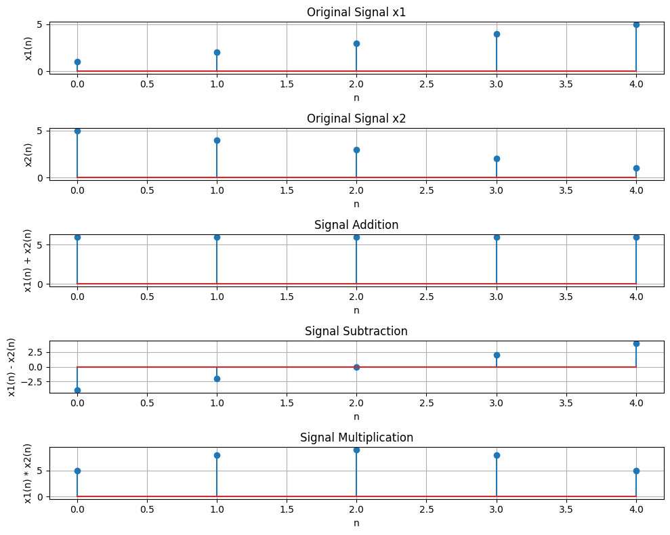

**Figure 02: Signal operation addition, subtraction, multiplication**

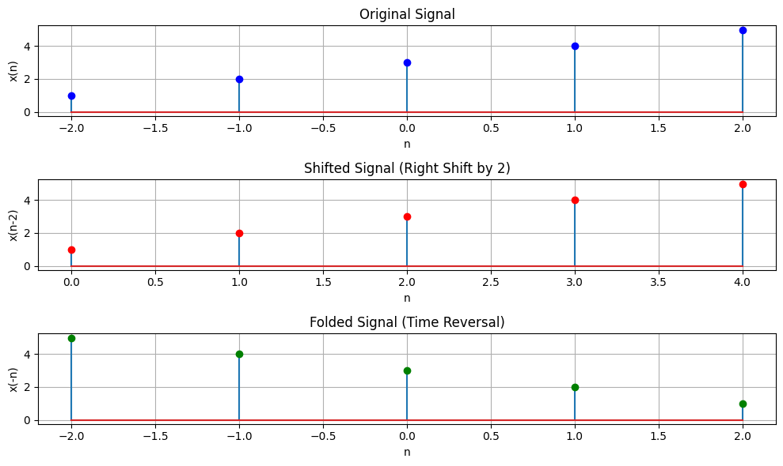

**Figure 03: Signal Shifting and folding**

**Experiment Number: 03**

**Experiment Name:** Convolution, Cross-Correlation, and Autocorrelation of Signals

**Objectives:**

1. To perform and visualize the convolution of a signal with a kernel.
2. To compute and plot the cross-correlation between two signals.
3. To compute and plot the autocorrelation of a signal.
4. To understand how correlation and convolution are related

**Theory:**

* Convolution is a mathematical operation that combines two signals to produce a third. It is commonly used in signal processing and image analysis. In discrete time, convolution is computed by flipping the kernel (or filter) and sliding it across the signal.
* Cross-correlation is similar to convolution but without flipping the kernel. It is used to measure the similarity between two signals.
* Autocorrelation is a special case of cross-correlation where the signal is correlated with itself. It is useful for identifying repeating patterns in a signal

**Source Code:**

import numpy as np

import matplotlib.pyplot as plt

from scipy.signal import correlate, correlation_lags

# Define signal and kernel

signal = np.array([1, 2, 3, 4, 5])

kernel = np.array([1, 0, -1])

# Perform convolution (same as cross-correlation with flipped kernel)

convolved_signal = np.convolve(signal, kernel, mode='full')

# Perform cross-correlation by flipping the kernel

correlated_signal = np.correlate(signal, kernel, mode='full')

# Plot signals

plt.figure(figsize=(10, 4))

# Plot the original signal

plt.subplot(1, 3, 1)

plt.stem(signal)

plt.title('Original Signal')

plt.grid(True)

# Plot the convolved signal

plt.subplot(1, 3, 2)

plt.stem(convolved_signal, linefmt='r', markerfmt='ro')

plt.title('Convolved Signal')

plt.grid(True)

# Plot the correlated signal

plt.subplot(1, 3, 3)

plt.stem(correlated_signal, linefmt='g', markerfmt='go')

plt.title('Correlated Signal')

plt.grid(True)

plt.tight_layout()

plt.show()

# Define autocorrelation function

def compute_autocorrelation(signal):

auto_corr = correlate(signal, signal, mode='full', method='auto')

lags = correlation_lags(len(signal), len(signal), mode='full')

return auto_corr, lags

# Define cross-correlation function

def compute_cross_correlation(signal1, signal2):

cross_corr = correlate(signal1, signal2, mode='full', method='auto')

lags = correlation_lags(len(signal1), len(signal2), mode='full')

return cross_corr, lags

# Sampling frequency and time vector

fs = 1000

t = np.linspace(0, 1, fs)

freq = 5

# Sinusoidal signal

signal1 = np.sin(2 * np.pi * freq * t)

# Autocorrelation of signal1

auto_corr, lags_auto = compute_autocorrelation(signal1)

# Cross-correlation with a shifted version of the signal

signal2 = np.roll(signal1, 100)

cross_corr, lags_cross = compute_cross_correlation(signal1, signal2)

# Cross-correlation with noisy signal

noise = np.random.normal(0, 0.5, fs)

noisy_signal = signal1 + noise

cross_corr_noise, lags_noise = compute_cross_correlation(signal1, noisy_signal)

# Plot all results in one figure

plt.figure(figsize=(12, 8))

# Autocorrelation plot

plt.subplot(3, 1, 1)

plt.plot(lags_auto, auto_corr)

plt.title("Autocorrelation of Sinusoidal Signal")

plt.xlabel("Lag")

plt.ylabel("Autocorrelation")

plt.grid(True)

# Cross-correlation plot (shifted signal)

plt.subplot(3, 1, 2)

plt.plot(lags_cross, cross_corr)

plt.title("Cross-Correlation between Original and Shifted Signal")

plt.xlabel("Lag")

plt.ylabel("Cross-Correlation")

plt.grid(True)

# Cross-correlation with noisy signal

plt.subplot(3, 1, 3)

plt.plot(lags_noise, cross_corr_noise)

plt.title("Cross-Correlation with Noisy Signal")

plt.xlabel("Lag")

plt.ylabel("Cross-Correlation")

plt.grid(True)

# Adjust layout and show the plot

plt.tight_layout()

plt.show()

**Output:**

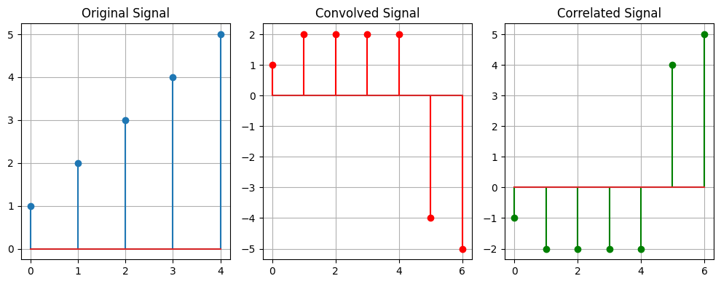

**Figure 04: Convolved and Correlated Signal**

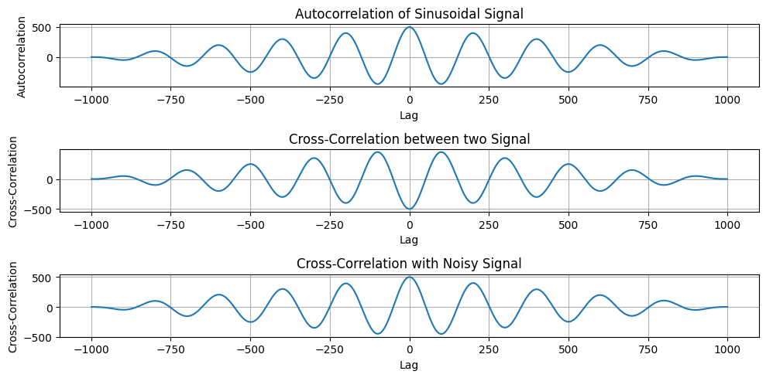

**Figure 05: Autocorrelation of Sinusoidal Signal**

**Experiment Number: 04**

**Experiment Name:** Processing and Heart Rate Detection from PPG Signal

**Objectives:**

1. To generate and visualize a raw sinusoidal signal, noise signal, and a simulated PPG signal.
2. To apply a bandpass filter to the PPG signal to remove unwanted noise.
3. To normalize the PPG signal to standardize the amplitude.
4. To detect heartbeats using peak detection and compute the heart rate in beats per minute (BPM).

**Theory:**

* PPG (Photoplethysmogram) is a non-invasive optical measurement used to detect blood volume changes, typically for heart rate monitoring.
* A bandpass filter is used to allow frequencies within a certain range to pass through, removing low-frequency noise (e.g., from baseline wander) and high-frequency noise (e.g., from muscle artifacts).
* Peak detection is used to identify the time points of heartbeats in the filtered PPG signal. The Inter-Beat Interval (IBI) is calculated from the time difference between consecutive peaks, and the heart rate is derived by converting the IBI into beats per minute (BPM).

**Source Code:**

*import* numpy *as* np

*import* matplotlib.pyplot *as* plt

*from* scipy.signal *import* butter, filtfilt, find_peaks

# *Signal parameters*

fs = 100

t = np.linspace(0, 10, fs * 10)

# *Generate signals*

sin_signal = 0.6 * np.sin(2 * np.pi * 1.2 * t)

# *Plotting*

plt.figure(figsize=(12, 10))

# *Subplot 1: Raw Sin Signal*

plt.subplot(3, 2, 1)

plt.plot(t, sin_signal)

plt.title("Raw Sin Signal")

plt.xlabel("Time (seconds)")

plt.ylabel("Amplitude")

noise_signal = np.random.normal(0, 0.05, len(t))

# *Subplot 2: Raw Noise Signal*

plt.subplot(3, 2, 2)

plt.plot(t, noise_signal)

plt.title("Raw Noise Signal")

plt.xlabel("Time (seconds)")

plt.ylabel("Amplitude")

ppg_signal = sin_signal + noise_signal

# *Subplot 3: Raw PPG Signal*

plt.subplot(3, 2, 3)

plt.plot(t, ppg_signal)

plt.title("Raw PPG Signal")

plt.xlabel("Time (seconds)")

plt.ylabel("Amplitude")

# *Bandpass filter function*

def bandpass_filter(signal, lowcut, highcut, fs, order=4):

    nyquist = 0.5 * fs

    low = lowcut / nyquist

    high = highcut / nyquist

    b, a = butter(order, [low, high], btype='band')

*return* filtfilt(b, a, signal)

# *Filter and normalize PPG signal*

filtered_ppg = bandpass_filter(ppg_signal, 0.5, 5, fs)

# *Subplot 4: Filtered PPG Signal*

plt.subplot(3, 2, 4)

plt.plot(t, filtered_ppg)

plt.title("Filtered PPG Signal")

plt.xlabel("Time (seconds)")

plt.ylabel("Amplitude")

normalized_ppg = (filtered_ppg - np.min(filtered_ppg)) / (np.max(filtered_ppg) - np.min(filtered_ppg))

# *Subplot 5: Normalized PPG Signal*

plt.subplot(3, 2, 5)

plt.plot(t, normalized_ppg)

plt.title("Normalized PPG Signal")

plt.xlabel("Time (seconds)")

plt.ylabel("Normalized Amplitude")

# *Detect peaks in the PPG signal*

peaks, _ = find_peaks(normalized_ppg, distance=fs * 0.6)

ibi = np.diff(peaks) / fs  # *Inter-beat interval in seconds*

heart_rate = 60 / ibi  # *Heart rate in BPM*

# *Subplot 6: PPG Signal with Detected Peaks*

plt.subplot(3, 2, 6)

plt.plot(t, normalized_ppg)

plt.plot(t[peaks], normalized_ppg[peaks], "x", label="Peaks")

plt.title("PPG Signal with Detected Peaks (Heartbeats)")

plt.xlabel("Time (seconds)")

plt.ylabel("Normalized Amplitude")

plt.legend()

plt.tight_layout()

plt.show()

# *Print Heart Rate*

print("Heart Rate: ", np.mean(heart_rate), " BPM")

**Output:**

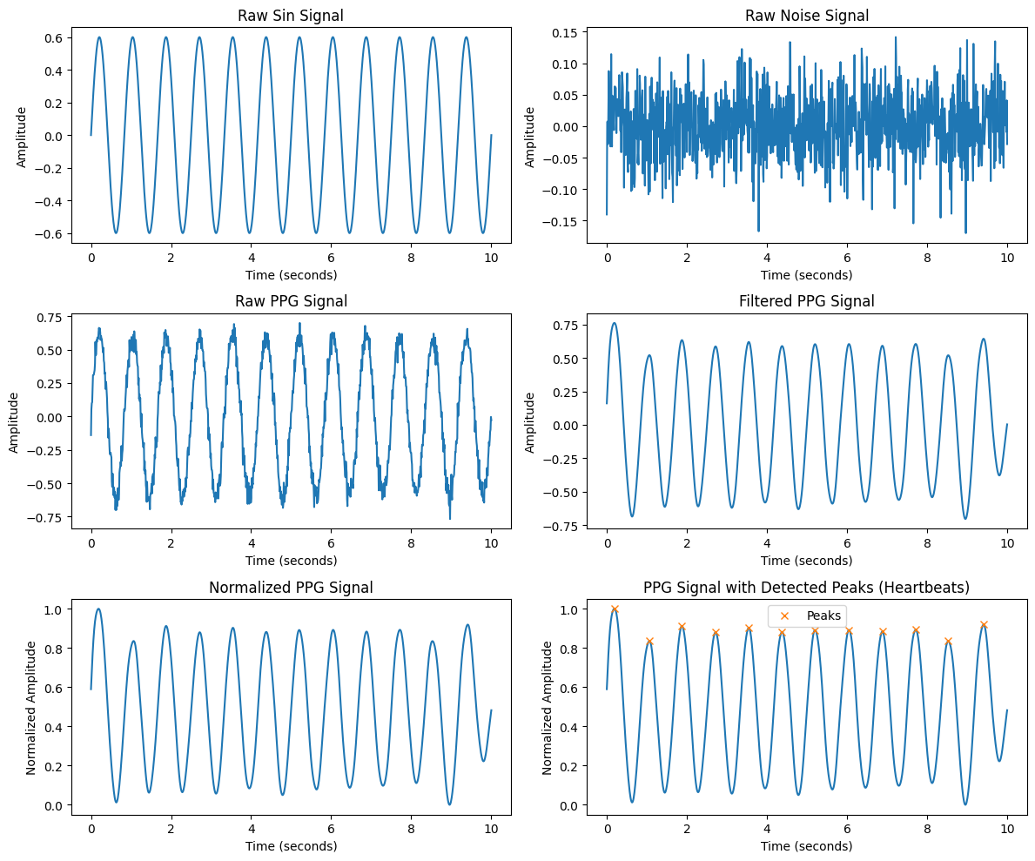

**Figure 06: PPG Signal Processing**

**Experiment Number: 05**

**Experiment Name:** Frequency Analysis and Filtering Using Discrete Fourier Transform (DFT) and Fast Fourier Transform (FFT)

**Objectives:**

1. To understand the Discrete Fourier Transform (DFT) and its computation.
2. To implement FFT for efficient frequency domain analysis.
3. To filter noise from a signal using FFT and Inverse FFT.
4. To visualize frequency components of a signal

**Theory:**

* The Discrete Fourier Transform (DFT) converts a time-domain signal into its frequency components, represented
* The Fast Fourier Transform (FFT) is an optimized algorithm for computing the DFT efficiently, reducing computational complexity from to. This is useful in signal processing applications such as filtering and spectral analysis.
* By applying FFT to a noisy signal and zeroing out high-frequency components, we can remove unwanted noise and reconstruct a cleaner version of the signal using Inverse FFT (IFFT**).**

**Source Code:**

import numpy as np

import matplotlib.pyplot as plt

# Compute the Discrete Fourier Transform (DFT)

def DFT(x):

N = len(x)

X = np.zeros(N, dtype=complex) # Output array (complex numbers)

for k in range(N): # Loop over frequency bins

for n in range(N): # Loop over time samples

X[k] += x[n] * np.exp(-2j * np.pi * k * n / N)

return X

# Create a sample signal (two sine waves)

Fs = 1000 # Sampling rate

T = 1 / Fs # Sampling interval

t = np.linspace(0, 1, Fs, endpoint=False) # 1 second duration

# Signal: Combination of 50 Hz and 120 Hz sine waves

f1, f2 = 50, 120

signal = np.sin(2 * np.pi * f1 * t) + 0.5 * np.sin(2 * np.pi * f2 * t)

# Compute DFT

dft_output = DFT(signal)

# Compute frequency bins

freqs = np.fft.fftfreq(len(dft_output), T)

# Plot magnitude spectrum (single-sided)

plt.figure(figsize=(10, 5))

plt.plot(freqs[:Fs//2], np.abs(dft_output[:Fs//2])) # Single-sided spectrum

plt.title("DFT Frequency Spectrum")

plt.xlabel("Frequency (Hz)")

plt.ylabel("Magnitude")

plt.grid()

plt.show()

import numpy as np

import matplotlib.pyplot as plt

from scipy.fft import fft, ifft, fftfreq

# Generate a sample audio signal

Fs = 1000 # Sampling rate (1000 Hz)

T = 1 / Fs # Sampling interval

t = np.linspace(0, 1, Fs, endpoint=False) # 1 second time vector

# Generate a pure sine wave (440 Hz, like an "A4" musical note)

freq_signal = 440

pure_signal = np.sin(2 * np.pi * freq_signal * t)

# Add random noise

noise = np.random.normal(0, 0.5, pure_signal.shape)

noisy_signal = pure_signal + noise

# Apply FFT

fft_signal = fft(noisy_signal)

freqs = fftfreq(len(fft_signal), T) # Frequency bins

# Filter: Remove frequencies higher than 500 Hz

fft_filtered = fft_signal.copy()

fft_filtered[np.abs(freqs) > 500] = 0 # Zero out high frequencies (noise)

# Apply Inverse FFT to get the cleaned signal

cleaned_signal = ifft(fft_filtered).real

# Plot the results

plt.figure(figsize=(12, 6))

plt.subplot(3, 1, 1)

plt.plot(t, pure_signal, label="Original Signal (440 Hz)")

plt.legend()

plt.title("Original Pure Signal")

plt.subplot(3, 1, 2)

plt.plot(t, noisy_signal, label="Noisy Signal", color="red")

plt.legend()

plt.title("Noisy Signal")

plt.subplot(3, 1, 3)

plt.plot(t, cleaned_signal, label="Cleaned Signal (After FFT Filtering)", color="green")

plt.legend()

plt.title("Filtered Signal (Noise Removed)")

plt.tight_layout()

plt.show()

**Output:**

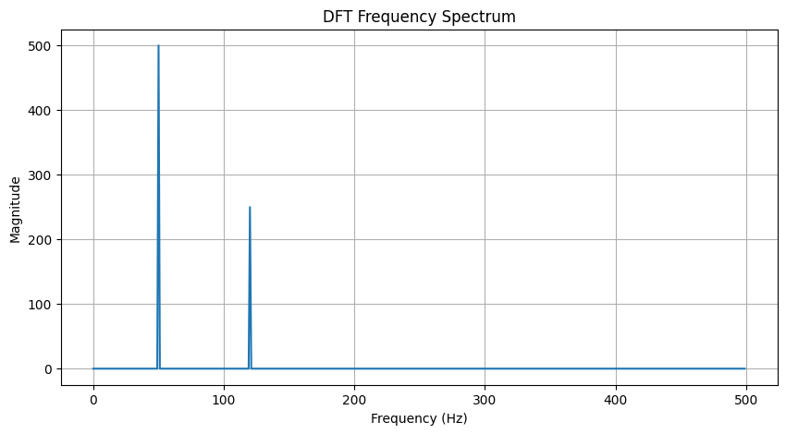

**Figure 07: DFT Frequency Spectrum**

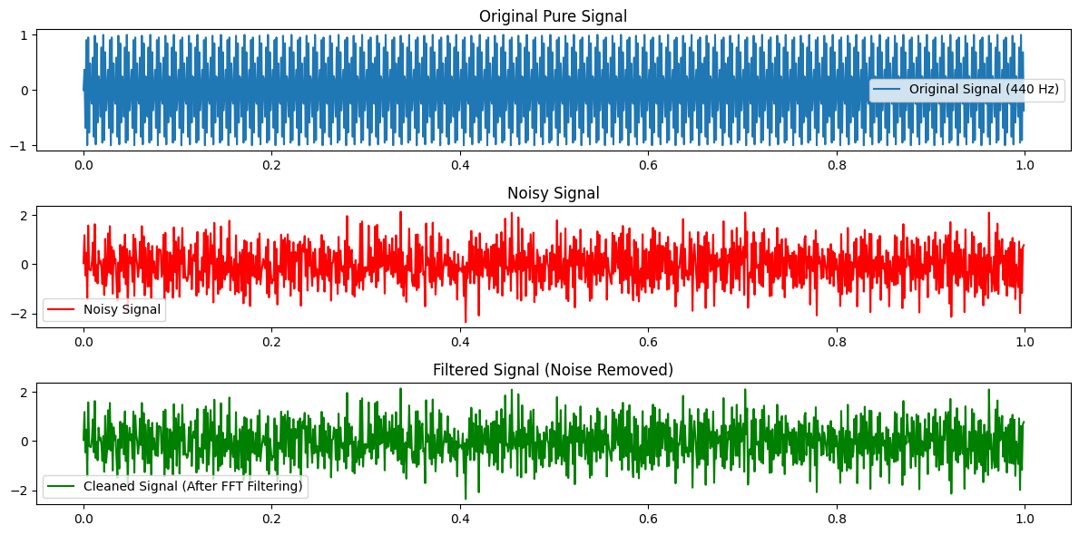

**Figure 08: Comparison of Original, Noisy, and Filtered Signals (FFT-Based Noise Removal)**